Social Media
Toolkit

**Do not copy/use any of the text in red. That is for internal purposes only**
The following are social media templates that can be customized with details relevant Elevate. Share one - or all – leading up to and during the conference. You are encouraged to tag team members on LinkedIn when appropriate, include your own imagery, and repost each other’s content.

10/1 - Post Option 1:
Nashville, here we come!
Looking forward to spending some time next week with the team at Elevate 2026. Getting everyone together is always a great opportunity to reconnect. Some of the best ideas come from simply getting the right people in the same room. Looking forward to seeing everyone there!
#AlliantPrivateClient #ELEVATE26 #AlliantElevates
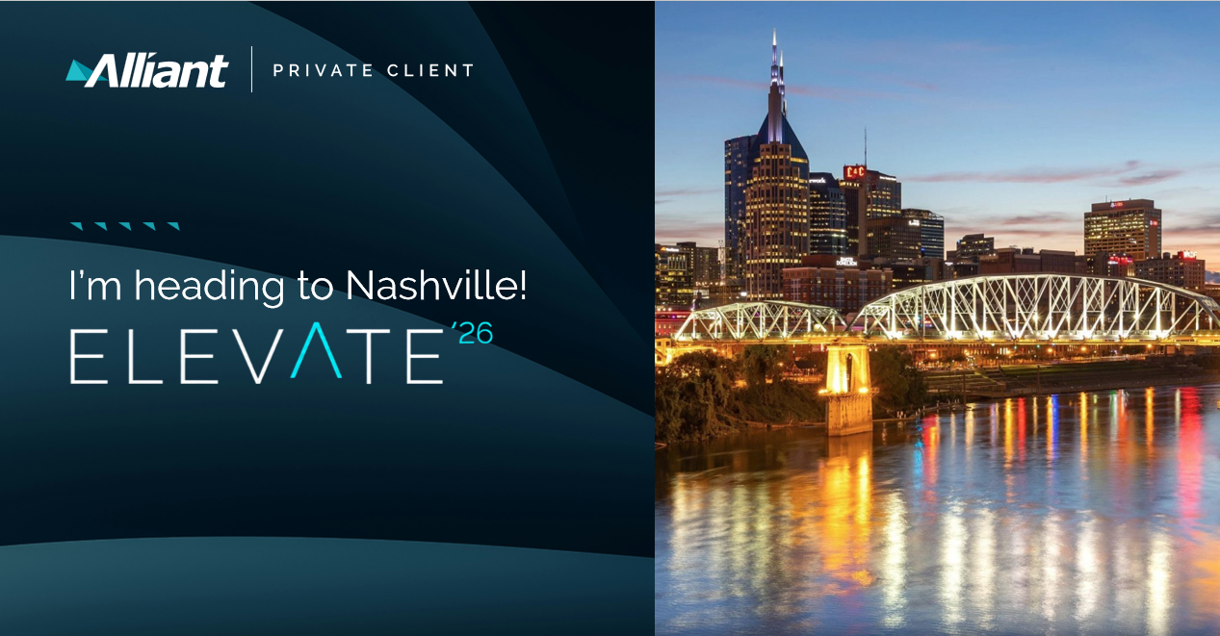
Directions: Save the image to your computer. When creating a post on LinkedIn, click the media icon at the bottom. Locate the saved image in your files, select it, and click Next once the preview appears.
**Important: We have been made aware of formatting issues when pasting text into LinkedIn. While we work on a solution, please try one of the following if you experience an issue:

- Paste the text into Notepad, then copy it from Notepad into LinkedIn.
or
- Copy the text and press Ctrl + Shift + V to paste it directly into LinkedIn.*

Post Option 2:
A great start to #ELEVATE26 here in Nashville.
One idea that stood out to me today came from [SESSION/SPEAKER]: [INSERT KEY TAKEAWAY/IDEA/PERSPECTIVE THAT STUCK WITH YOU.]
It’s always valuable to hear new perspectives and insights to bring into our conversations with clients and our partners. For me, it also reinforces the impact @AlliantInsuranceServices continues to have on the market and how our @AlliantPrivateClient team contributes to that story.
Excited for more conversations tomorrow.
#AlliantPrivateClient #ELEVATE26 #AlliantElevates
ADD IN YOUR PICTURES FROM THE EVENT
Instructions:
Choose one takeaway rather than summarizing the whole session. What made you stop and think? What could be useful to your clients, referral partners or professional network?
Pair the post with 1–3 photos from the session, speaker, team dinner or other moments from the day.
**Important: We have been made aware of formatting issues when pasting text into LinkedIn. While we work on a solution, please try one of the following if you experience an issue:
- Paste the text into Notepad, then copy it from Notepad into LinkedIn.
or
- Copy the text and press Ctrl + Shift + V to paste it directly into LinkedIn.**

Then, to automatically tag Alliant and Alliant Private Client in your post type the “@” symbol followed by the name Alliant Insurance Services and Alliant Private Client. Select the appropriate name and logo from the drop-down menu that appears.

Post Option 3:
There’s a lot of experience and expertise across this team, but what always stands out to me is how willing people are to share it. Being together in person is a great reminder of how much we learn from one another. Proud to be part of this team.
#AlliantPrivateClient #ELEVATE26 #AlliantElevates
ADD IN YOUR PICTURES FROM THE EVENT

10/9- Post Option 4:
Heading home from Nashville feeling grateful for three days of education, collaboration, and fun!
I’m grateful for the time together and look forward to bringing those conversations back to the work we do for our clients.
#AlliantPrivateClient #ELEVATE26 #AlliantElevates
ADD IN YOUR PICTURES FROM THE EVENT

